Lab 9

Student: Toleubek Assiya

ID: 23B150271

Part 1: Setting Up the Environment

Option A: MongoDB Atlas (Recommended)
- Go to MongoDB Atlas and sign up for a free account.
- Create a free shared cluster (M0 tier). It takes a few minutes.
- Once the cluster is ready, click Connect → Connect with MongoDB Shell and copy the connection string.
Alternatively, use the built-in MongoDB Compass or the Data Explorer (web UI) to run queries.

Option B: Online Playground (Quick, no account)
- Use MongoDB Playground.
This is a temporary sandbox where you can run MongoDB queries without any setup. Data is not persisted, but it’s perfect for practicing the syntax.

Part 2: Sample Dataset

2.1 Create and Insert into products
_id:
name:
price:
category:
tags:
stock:
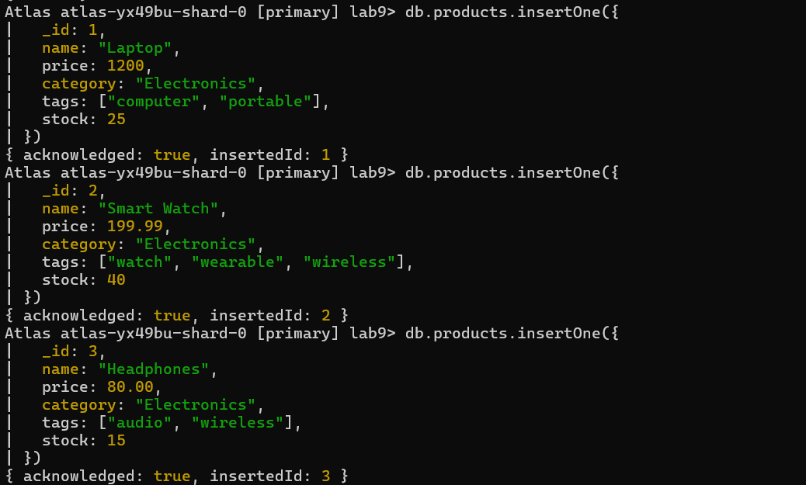
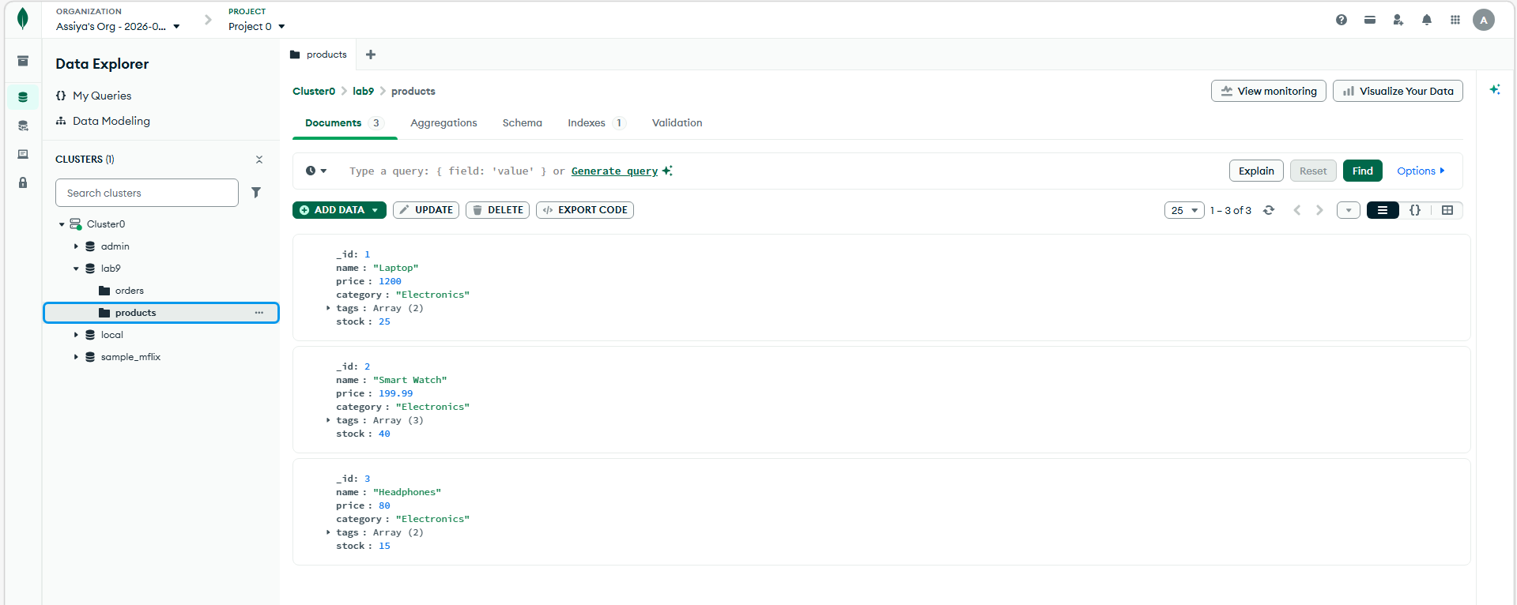

2.2 Create and Insert into orders
_id:
customer:
date:
items:
total:
status:
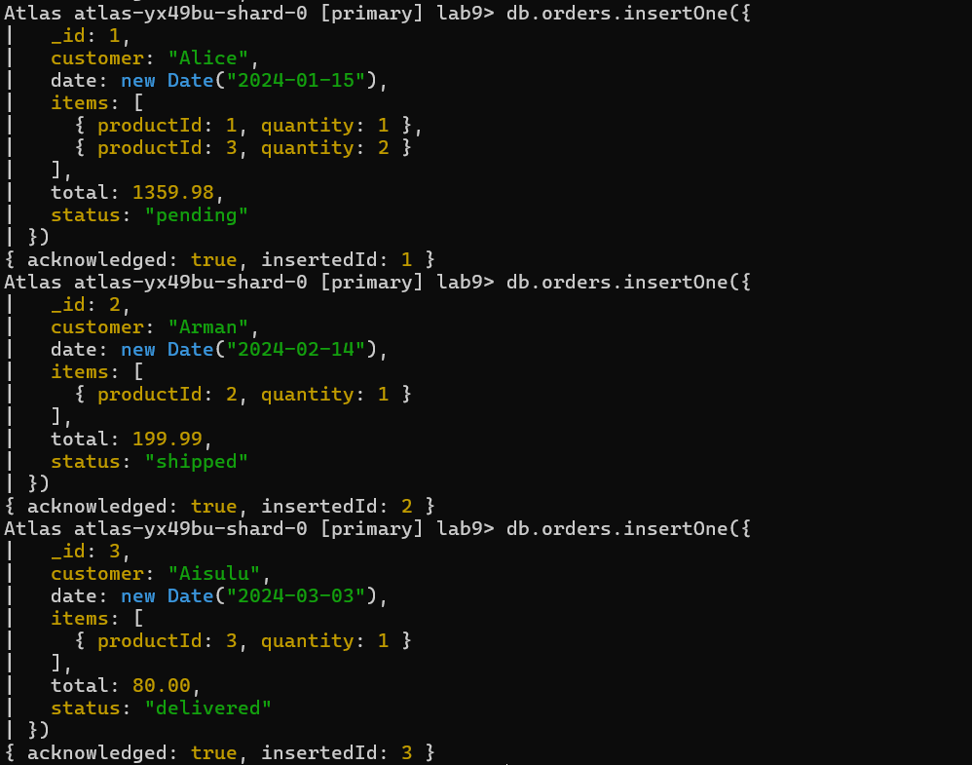
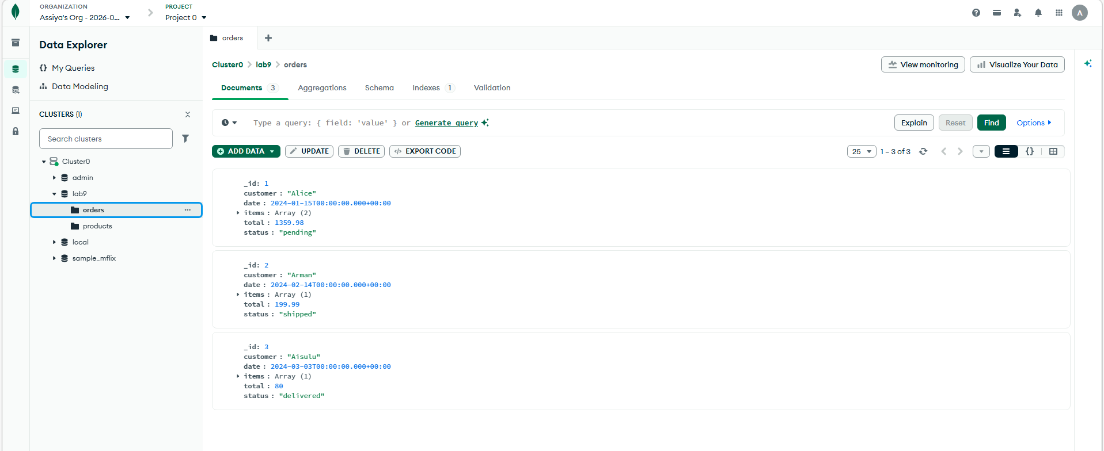

In this part, we created the products and orders collections and inserted sample data. The products collection stores information about items such as name, price, category, tags, and stock. These collections will be used to practice CRUD operations, queries, and aggregation in MongoDB.

Part 3: Basic CRUD Operations

Task 3.1 – Find
- Find all products in the products collection.
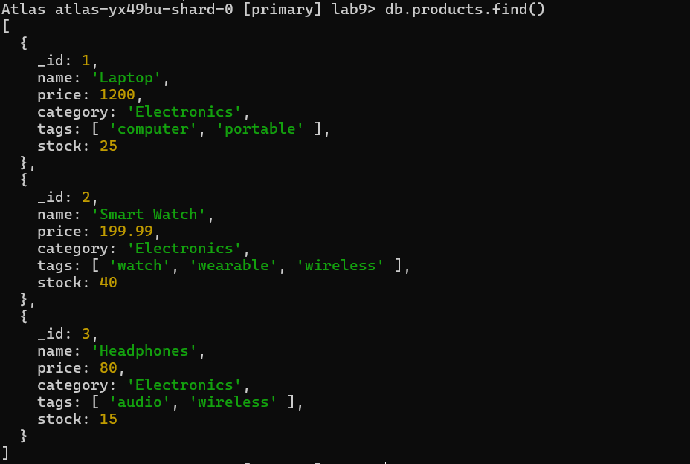
- Find all electronics (category: "Electronics") and display only the name and price(projection).
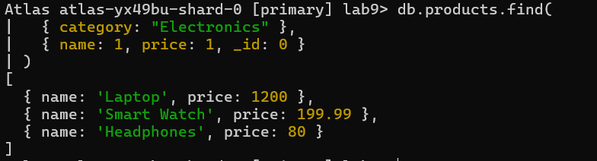
- Find products with price > 50 and sort them by price descending.
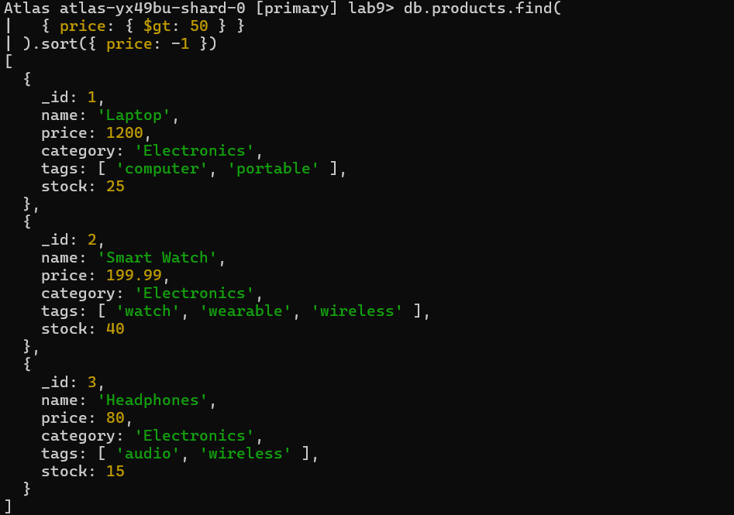

Task 3.2 – Insert
- Insert a new product with _id: 6, name: "Bluetooth Speaker", price: 49.99, category: "Electronics", tags: ["speaker", "audio"], stock: 60.
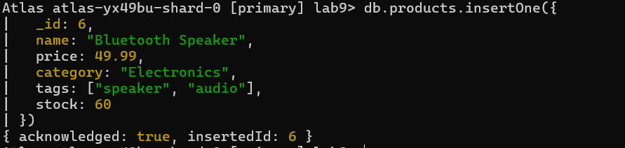
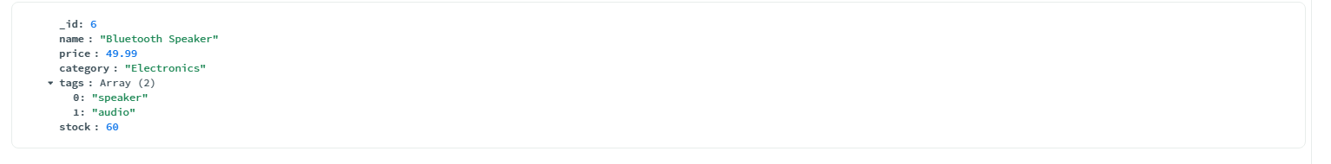

Task 3.3 – Update
- Increase the price of all electronics products by 10% (use $mul operator).
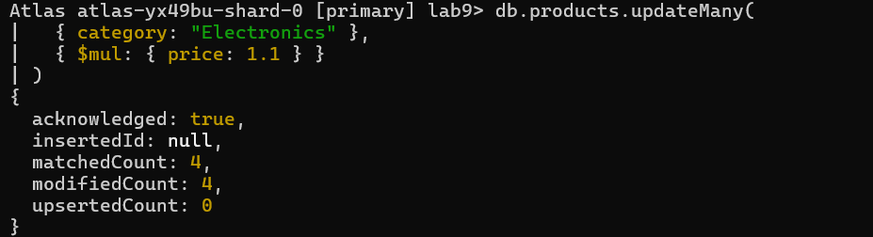

- Add a new tag "best-seller" to the product named "Smart Watch" (use $push to add to array).
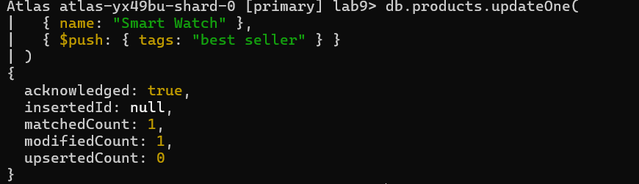
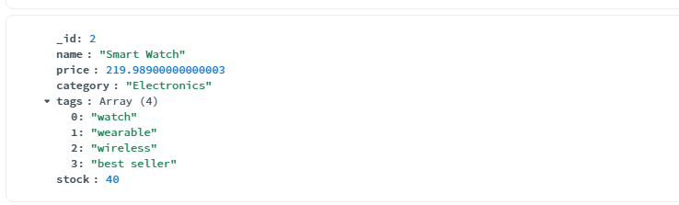

Task 3.4 – Delete
- Delete the product with _id: 6 (the Bluetooth Speaker).
- Delete all products with stock less than 10 (if any; you may insert a low-stock product for practice).
In this part, we performed basic CRUD operations on the products collection. We retrieved documents using find queries, inserted a new product, updated existing documents using $mul and $push operators, and deleted documents using deleteOne and deleteMany. These operations demonstrate how MongoDB handles Create, Read, Update, and Delete functionality.

Part 4: Querying with Operators
Write queries for the following:
- Find products whose price is between 20 and 100 (inclusive).
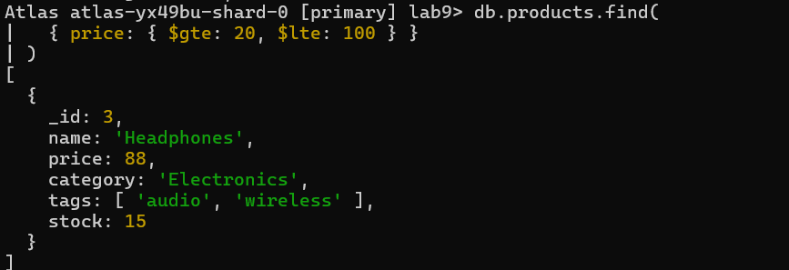
- Find orders that have status either "pending" or "shipped".
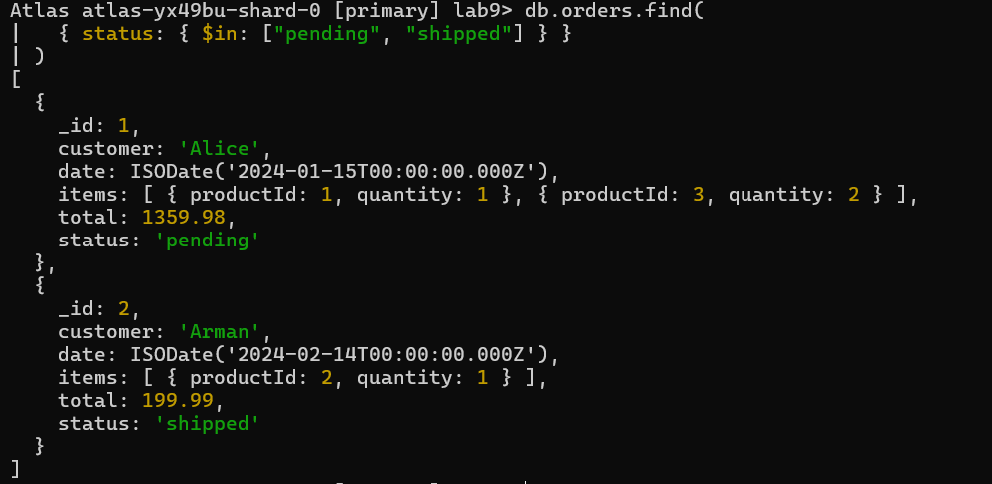
- Find products whose tags array contains the word "wireless".
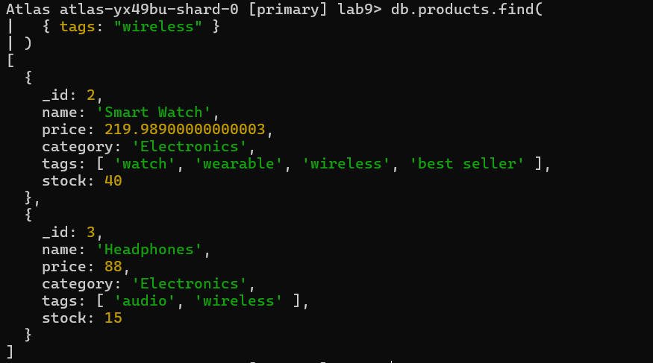
- Find orders where the customer is not "Alice".
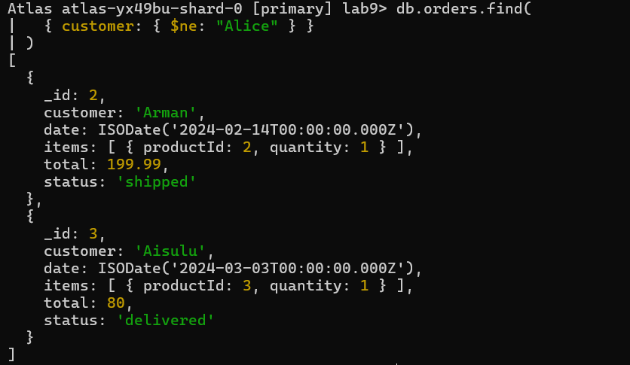
In this part, I worked with the products collection to practice CRUD operations. I found documents with different conditions, inserted a new product, updated prices and tags using $mul and $push, and deleted products by ID or stock level. This helped me understand how to manipulate data in MongoDB.

Part 5: Aggregation Pipeline
Use the aggregation framework to answer these questions:
- Total revenue from all orders (sum of the total field in orders).
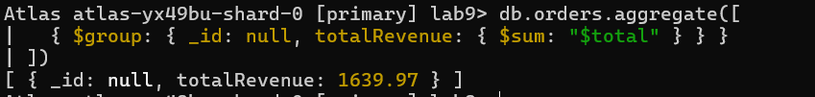
- Average order value per customer.
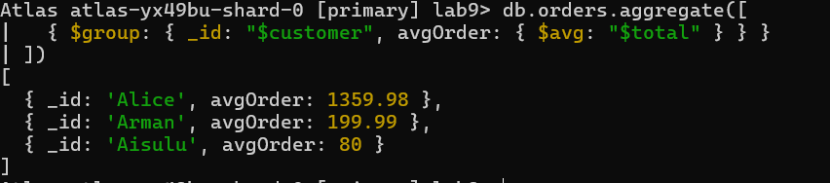
- Top-selling products:
Unwind the items array in orders, group by productId, sum the quantities, then join with products collection to get product names.
(Hint: use $lookup to bring product details.)
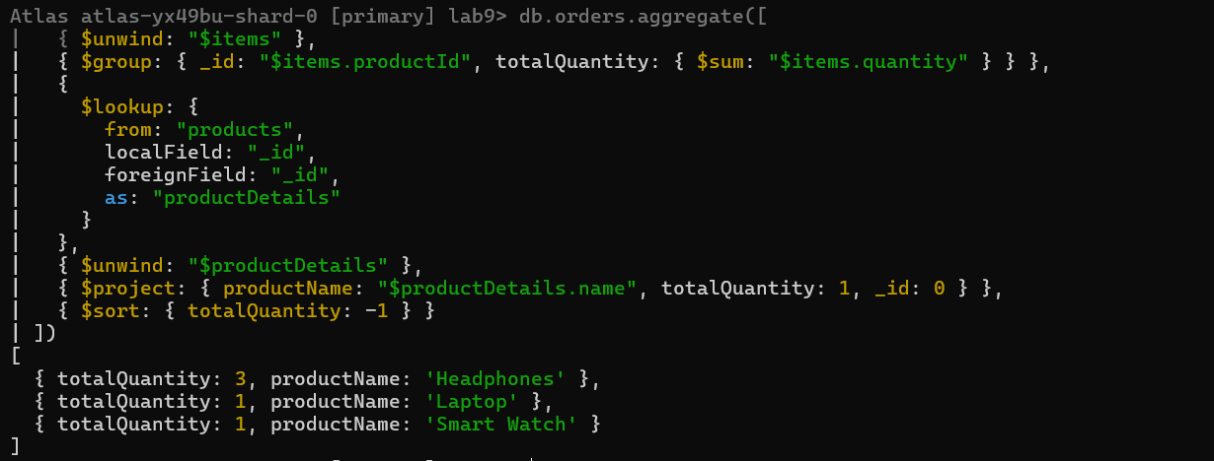
- Monthly order count – group orders by month and count how many orders were placed each month.
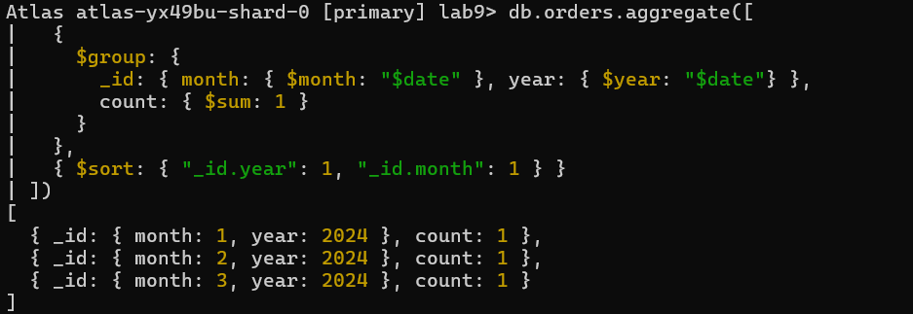
In part 5, I used the MongoDB aggregation framework to analyze data from the orders collection. I calculated total revenue, average order value per customer, identified top-selling products using $unwind and $lookup, and counted monthly orders. This helped me understand how to aggregate, group, and join data in MongoDB efficiently for reporting and analytics.

Part 6: Schema Design – Embedding vs. Referencing
Given the following requirements, decide whether to embed or reference the data. Explain your reasoning.
Scenario A:
A blog where each post has many comments. Comments are frequently read together with the post, but also need to be reported on separately (e.g., count comments per user). Would you embed comments inside the post document or store them in a separate collection with a reference? Why?
Referencing-store comments in a separate collection and reference the post ID.
Since comments are frequently read together with the post but also need to be analyzed separately, it is better to store comments in a separate collection and reference the post ID. Embedding all comments inside the post could make the document very large and harder to manage. Using referencing allows efficient querying of posts with comments while also enabling separate analytics, such as counting comments per user.

Scenario B:
A product catalog where each product has hundreds of reviews. The product page must display reviews, and users often search for their own reviews. Would you embed reviews in the product document or use referencing? Justify.

Referencing-store reviews in a separate reviews collection and reference the product ID.
Each product can have hundreds of reviews, and users often want to search for their own reviews. Embedding all reviews inside the product document would quickly make it very large and could exceed MongoDB’s document limit. Therefore, it is better to store reviews in a separate collection and reference the product ID. This approach allows displaying reviews on the product page and also querying individual reviews efficiently, while keeping the product documents manageable.

Part 7: Indexing Concept (No Code)
- Explain why an index on the customer field in the orders collection would speed up queries that filter by customer.
An index on the customer field allows MongoDB to quickly locate all orders for a specific customer without scanning the entire collection.
Without an index, MongoDB has to check every document in the collection which is slow for large datasets.
With the index, the database can jump directly to the relevant documents, making queries much faster and more efficient.

- Suggest two fields in the products collection that you would index to improve search performance. Justify your choices.
Name: Indexing the product name improves search performance when users search for a specific product by name, which is very common in a catalog or e-commerce application.
Category: Indexing the category field speeds up queries that filter products by category, such as “Electronics” or “Home,” which is useful for displaying category-specific lists efficiently.

